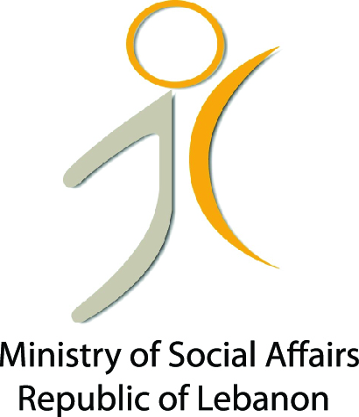
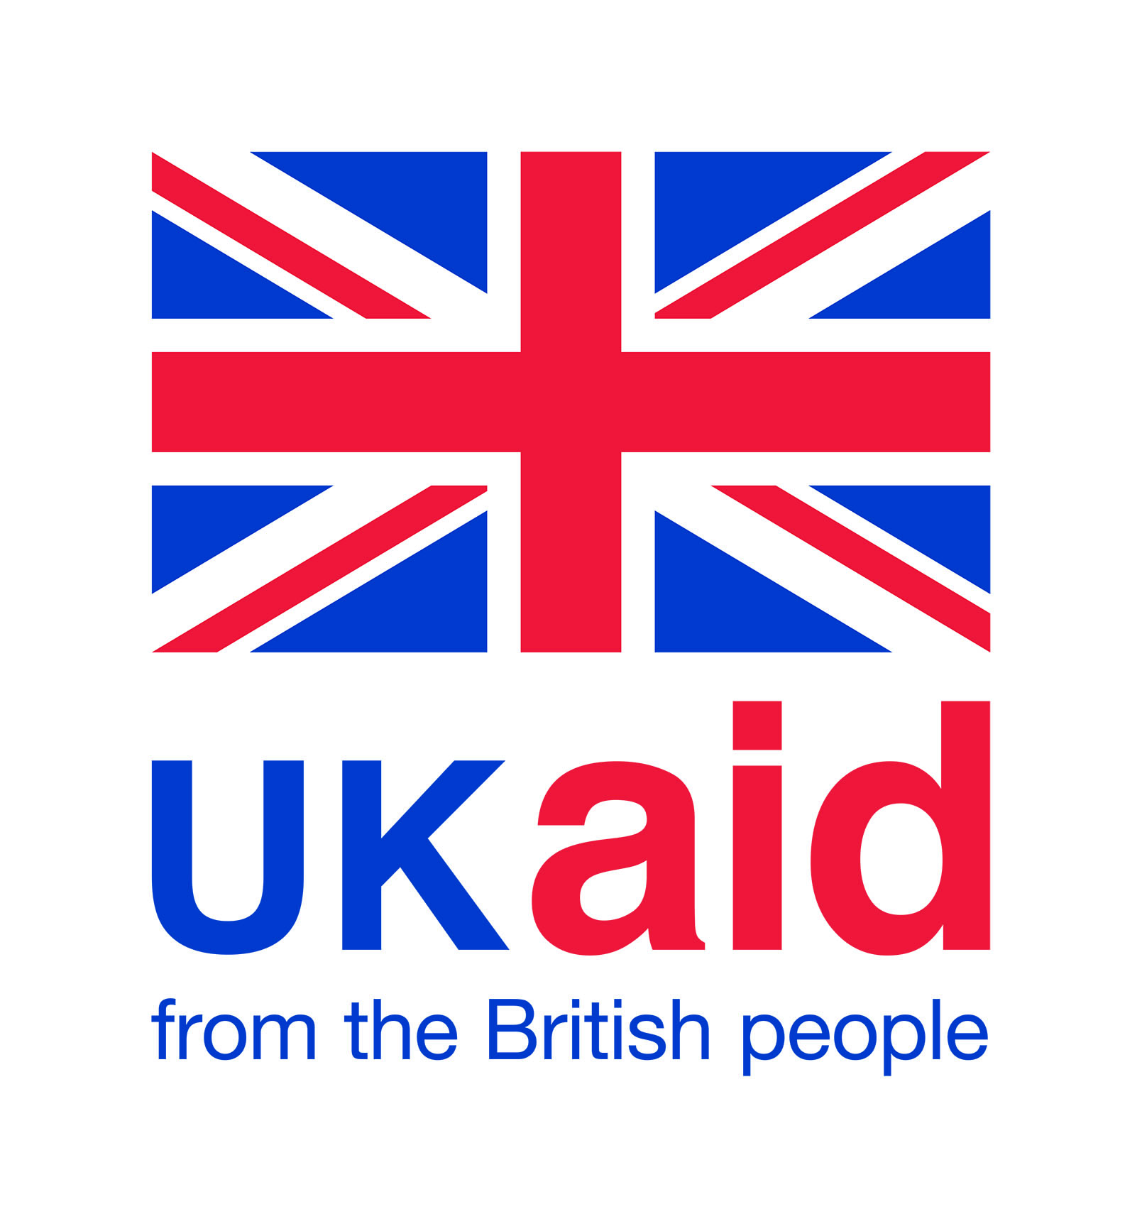
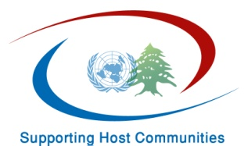
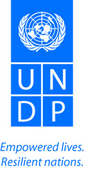

Quarterly Progress Report Number 1
Period:
July-September 2014

Summary Table
Executing Agency:

Country:

Project:

Project Duration:

Total Funds Allocated:

Reporting Period:

Contact Person:

Project Background:

Implementation Progress:
Two main activities under Social Cohesion component were implemented:
- The “Conflict Mapping/Analysis “and
- “Crisis and Conflict Management”

- For the Conflict Mapping/Conflict Analysis activity:
- In the framework of the partnership that was signed between UNDP and Lebanon Support NGO, and after a consultative meeting with key experts in conflict mapping, an interactive and collaborative conflict profiling platform and mapping system was developed and launched online and has become public for everyone. This platform is a visual interface to explore conflict-related data and analysis in Lebanon. The system aims at providing different partners involved in peace building, humanitarian and stabilization activities in the country with accurate data and relevant information on areas prone to conflict. The system tracks incidents, protests, and conflicts between individuals, groups, and communities and maps their location throughout Lebanon and is continuously updated. The map is still under development and new features will be added in the coming weeks based on feedback from viewers. It currently provides users with different means and tools to browse and read different conflict incidents reports through various categorization schemes. Reports can be generated based on dates, locations, types of incidents, and number of individuals injured or the number of deaths resulting from conflicts. The system can also generate reports based on different classifications of conflicts. The classification of conflicts include: Boundary conflicts (Lebanon/Israeli occupation); Boundary conflicts (Lebanon/Syria); Individual acts of violence; Conflicts of social discrimination; Conflicts of socio-economic development; Power and governance conflicts; and Policy conflicts. Users are able to filter out results based on these indicators and assess trends and locations of conflict in Lebanon.
The data collected in the mapping system is based primarily on media reports which are validated by cross-checking reports using different sources, and are then mapped, categorized and classified and published on the map. To access the map: http://cskc.daleel-madani.org/cma

- The project will also be producing quarterly qualitative analysis of conflict dynamics and particular trends, focusing on a different geographic location every time. The first report will be out by end of October focusing on the Bekaa region.

- Crisis and Conflict Management activities:
- As agreed in the workplan, the project is working on implementing local peace mechanisms in three clusters of villages: Zahle, South and Wadi Khaled. In regards to Wadi Khaled, and as part of the methodology, the first step has to do with conducting a locally lead conflict analysis. Representatives from the eight municipalities of Wadi Khaled: Wadi Khaled; Amayer; Bani Sakher; El Hishi; Al Rama; El Mqaibleh; Al Fard; Khat el Petrol took part in this exercise. A series of meetings and focus groups were organized for this purpose, and eight in-depth interviews in order to gather information and data for the purpose of informing the conflict analysis exercise were conducted by a technical consultant.
- During these sessions, almost all participants stressed on the impact of the Syrian crisis on infrastructure and basic services which is being one of the main sources of tensions and which might lead to serious conflicts in the near future.
In regards to the impact of the crisis on the Lebanese-Syrian relationships they all agreed that until now no major tensions exist but they all suspect eventually an escalation of conflicts at this level. Some people even fear of “another Arsal in Wadi Khaled since the phenomena of ISIS is starting to become present in the area”.
- In this framework, many participants to the conflict analysis exercise considered that any conflict prevention type of activities is indeed very much needed in order to stop any potential escalation of tensions; and thus considered that what UNDP is doing for establishing local peace mechanisms and medium to long term strategies for social cohesion is very important and timely.

Implementation Arrangements:
- Relationship / coordination with Ministry of Social Affairs
- Relationship with DFID/UK to serve the host communities
- Organigram outlining the project team structure
Challenges:

- The security situation during the past three months was very difficult. Access to Wadi Khaled was prohibited which delayed the implementation of the work
- The pressure the municipalities are facing from all parties and organizations and their tight schedules
Lessons Learned:

The methodology used for the conduction of the conflict analysis adopted an individualized approach targeting each and every municipality taking input from each side in order to capture all elements of the conflicts, all dynamics, trends, etc., even though the process targets the cluster of the eight villages all together . The individual meetings through the in depth interviews conducted proved to be very important in building trust and providing a safe space for people to express freely about the inter and intra local conflict in their villages. Many interviewees have expressed that each municipality has its privacy and each mayor or deputy mayor needs a private space sometimes to express honestly and in a transparent manner his perception / opinions / needs in the area / local conflicts between the villages and conflicts.

Financial Status:

- Actual expenditures as of to date.

 | Total Budget | Received Amount | Expenditure | Commitment | Remaining
Total Amount | $555,000.00 | $555,000.00 | $49,990.63 | $233,895.15 | $271,114.22
8% F&A | $44,400.00 | $44,400.00 | $3,999.25 | $18,711.61 | $21,689.14
Grand Total | $599,400.00 | $599,400.00 | $53,989.88 | $252,606.76 | $292,803.36
 |  | 100.00% | 51.15% |  | 48.85%

- Commitments for next tranche.

Reporting on Results and Impact:
Outcome | Outcome Indicators | Target | Progress | Pending Issues / Reasons for Adjustments
Output | Output Indicators | Target | Progress | Pending Issues / Reasons for Adjustments

Planning for the Next Period:

- By the end of October the first conflict analysis report will be produced
- The conflict analysis reports for Zahle and South clusters of villages will be ready and the work
- The identification of the response mechanisms or the social cohesion strategies will be launched for Zahle, South and Wadi Khaled clusters

Annexes:
- Annex A: Key events / project activities

- Annex B: Procurement schedule

